For my capstone project I’ll be completing project C. To convert this from console to GUI I’ll have a main screen that will has a listbox to display the current customer list and buttons for the add, remove, display, help, update, and exit commands. The add, remove, update, and help buttons will need popup dialog boxes to get the users input and will just make the program function better.

Activity Diagram:  
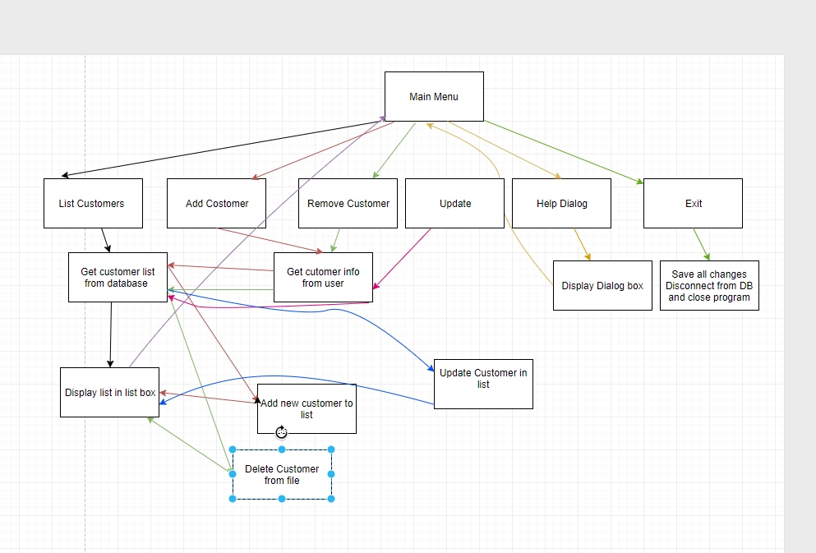

Fairly simple but this is adequate for me to understand how the flow of the program should work

Class Diagram

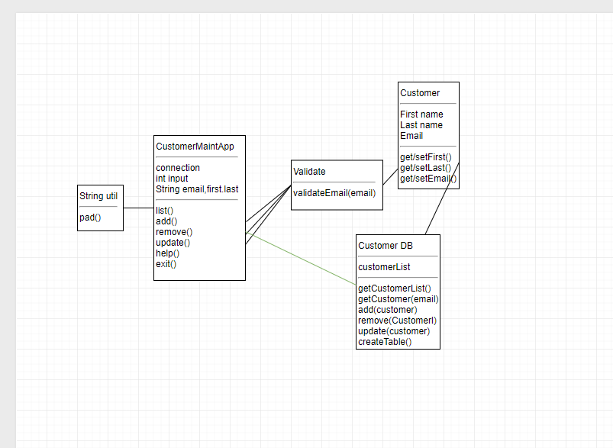

I could not for the life of me get my head around how to create one of these but I can explain how the classes should interact so:

The list() will call the getCustomerList() from the Customer DB and then use the String util pad() to display it properly.

The add() will take the inputs and validate the email to create a customer object. This will then be sent to the Customer DB where the add(customer) function will be called. Finally, list() will be called again to show the update.

The remove() will just take the email from the user, validate it, then call run the remove(customer) function from the Customer DB and finally, call list() to update.

The update() will take the email first, validate it and make sure the customer exists, then take the other inputs and call the update(customer) function and finally, call list() to update.

The helo() just displays the help box and doesn’t interact with the other classes

Exit() exists the program